**Python Operators**

**1. Arithmetic Operators:**

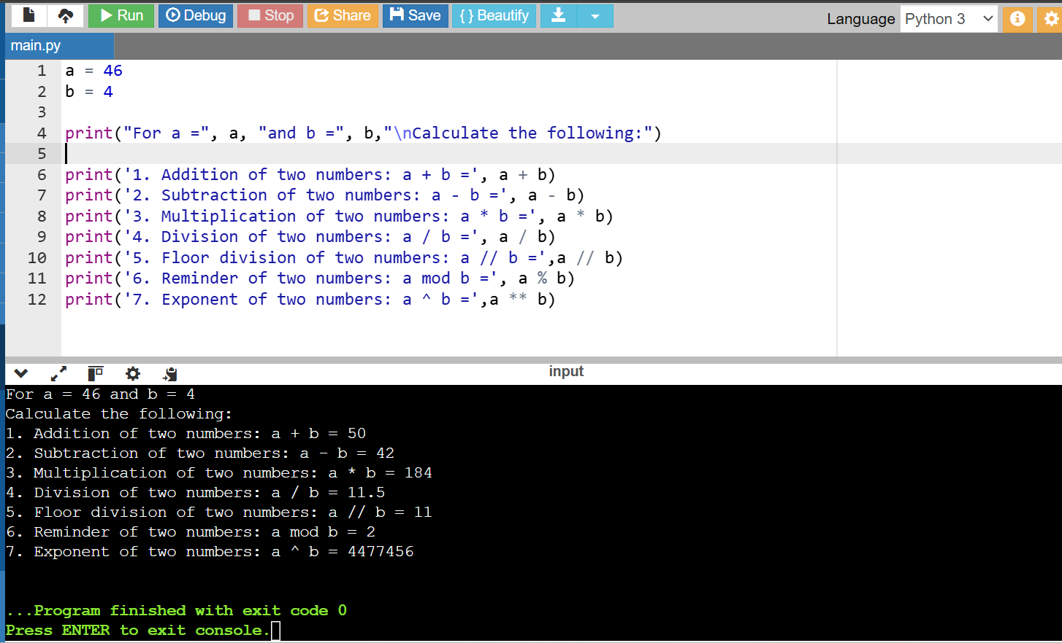

**2. Comparison Operators:**

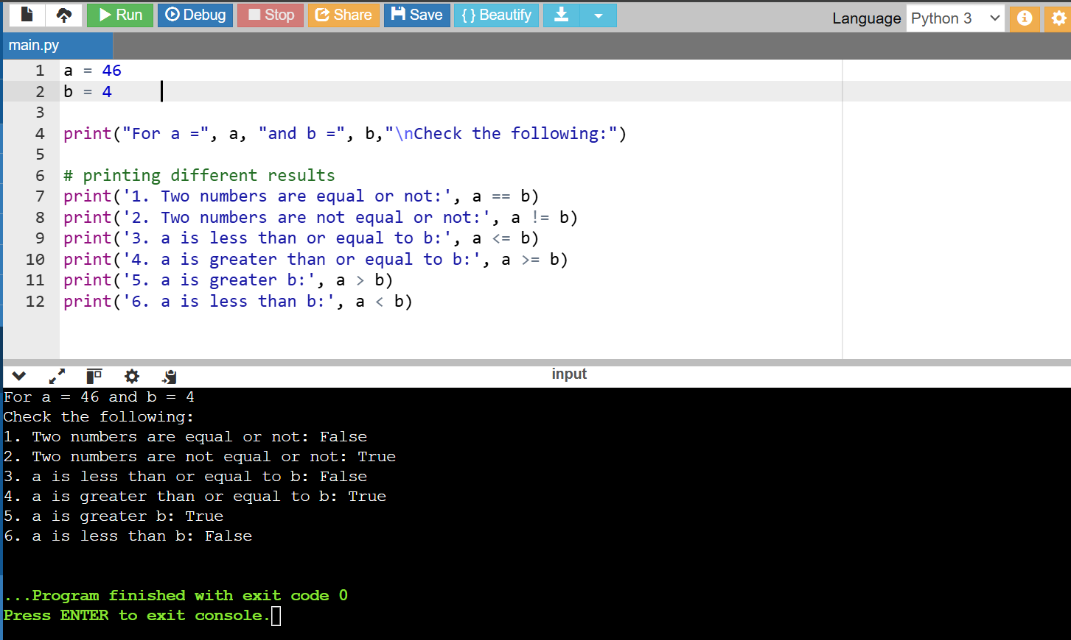

**3. Assignment Operators:**

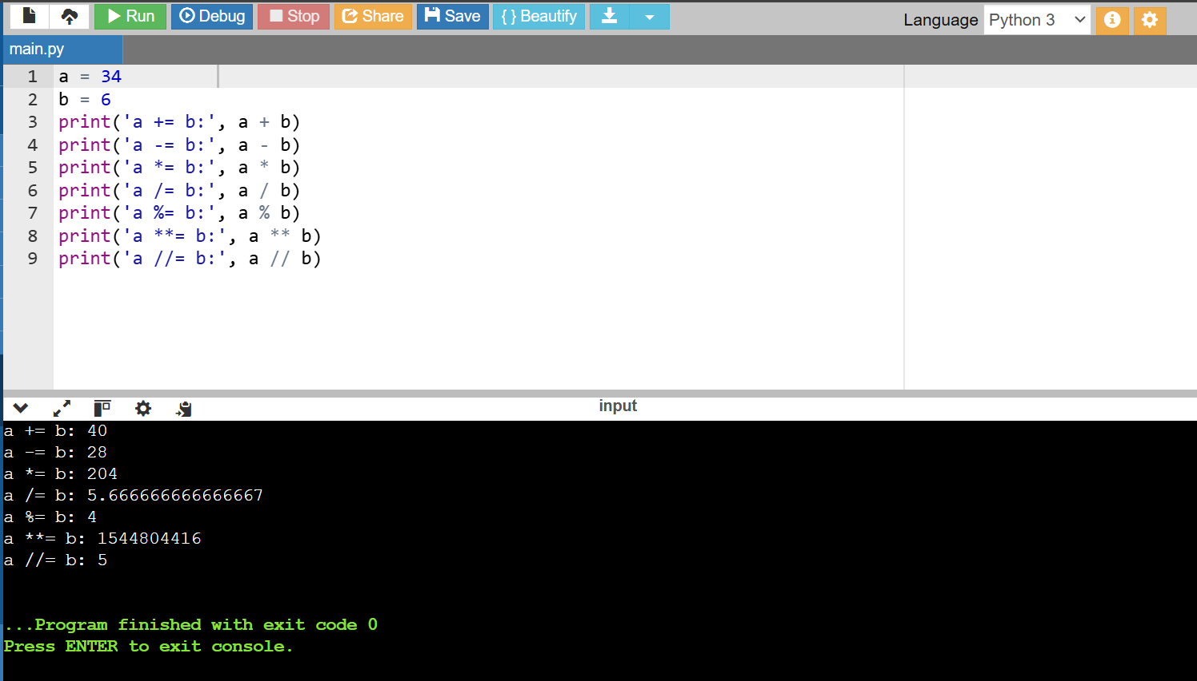

**4. Bitwise Operators:**

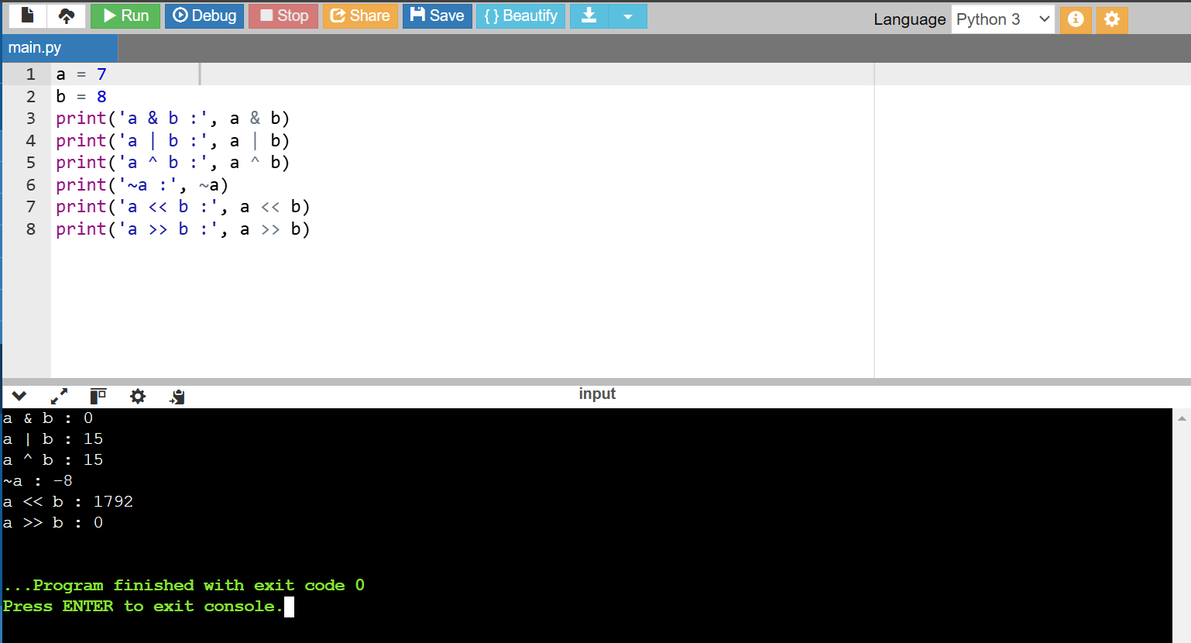

**5. Logical Operators:**

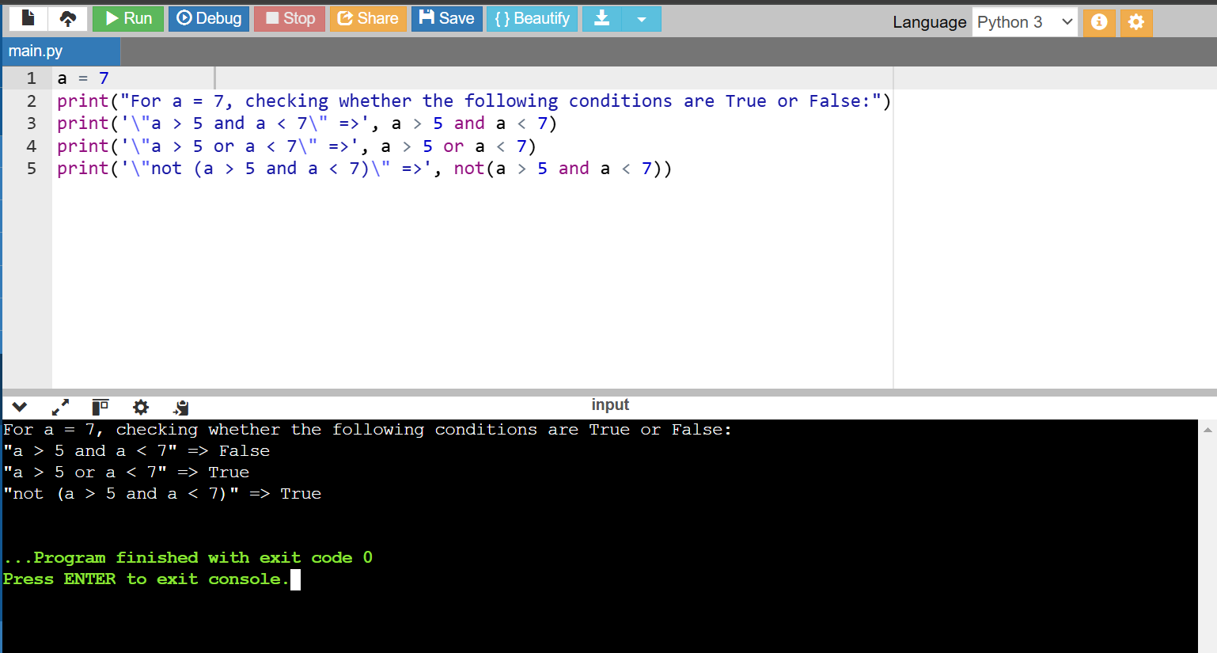

**6. Membership Operators:**

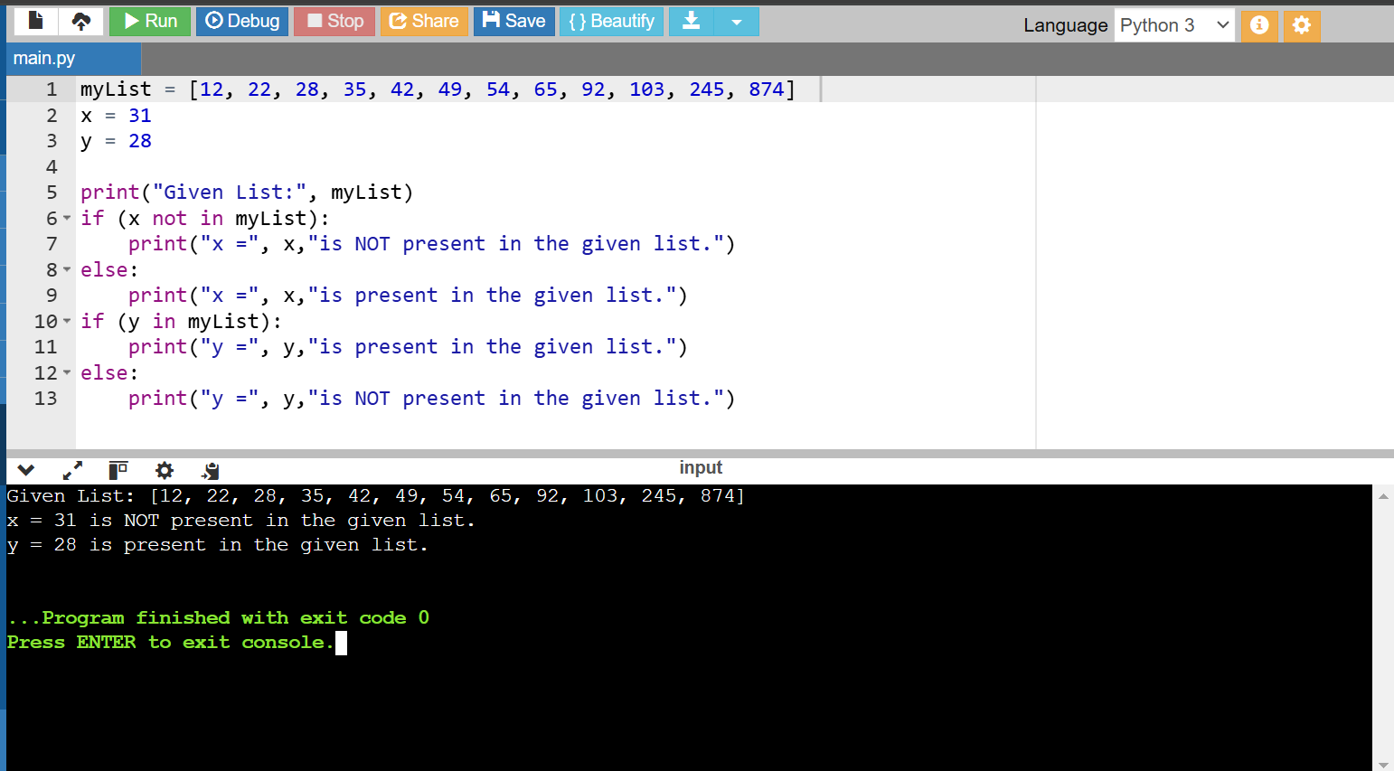

**7. Identity Operators:**

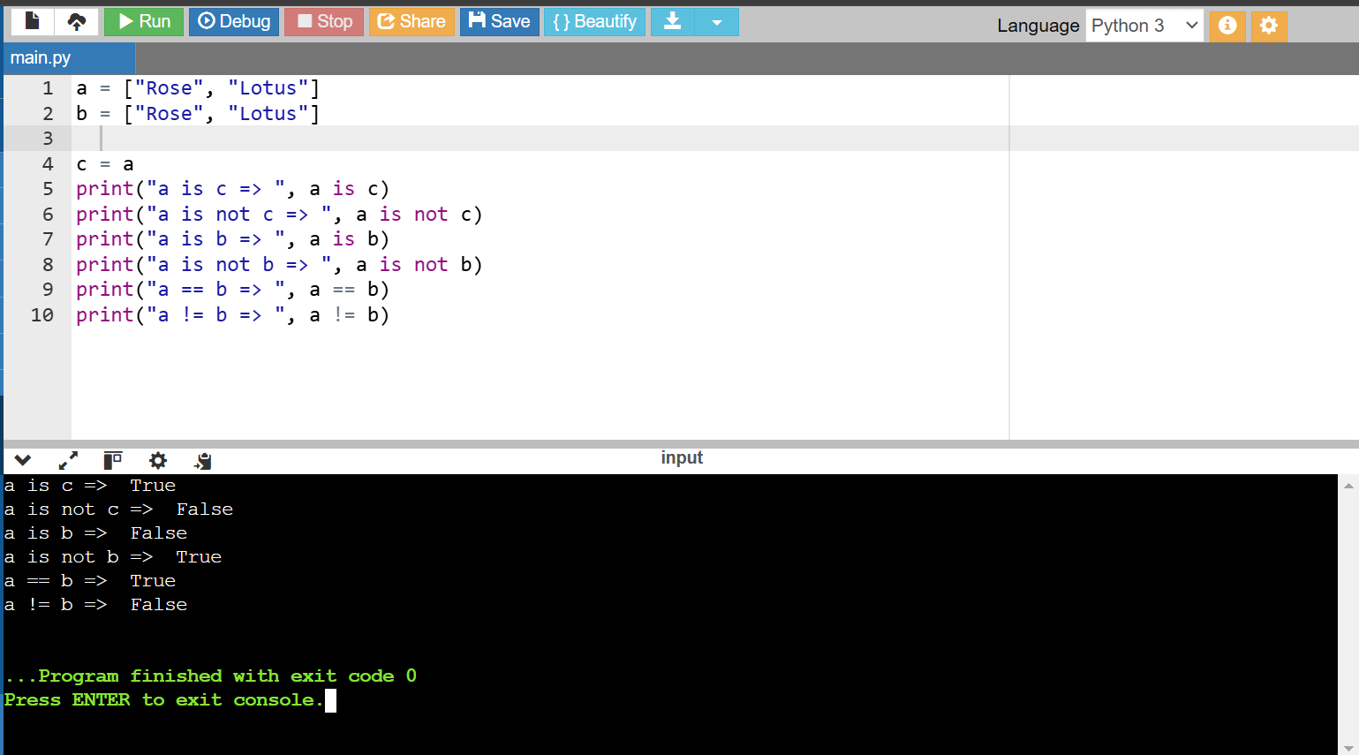

**REVERSE A STRING IN PYTHON:**

**1. Using for loop:**

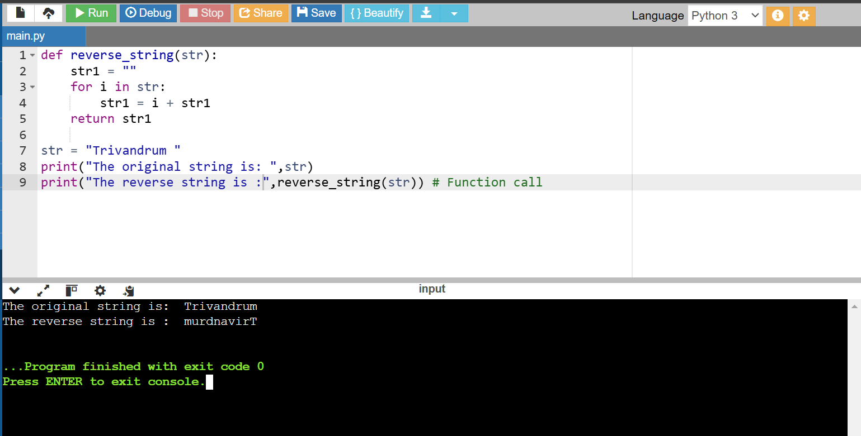

**2. Using while loop:**

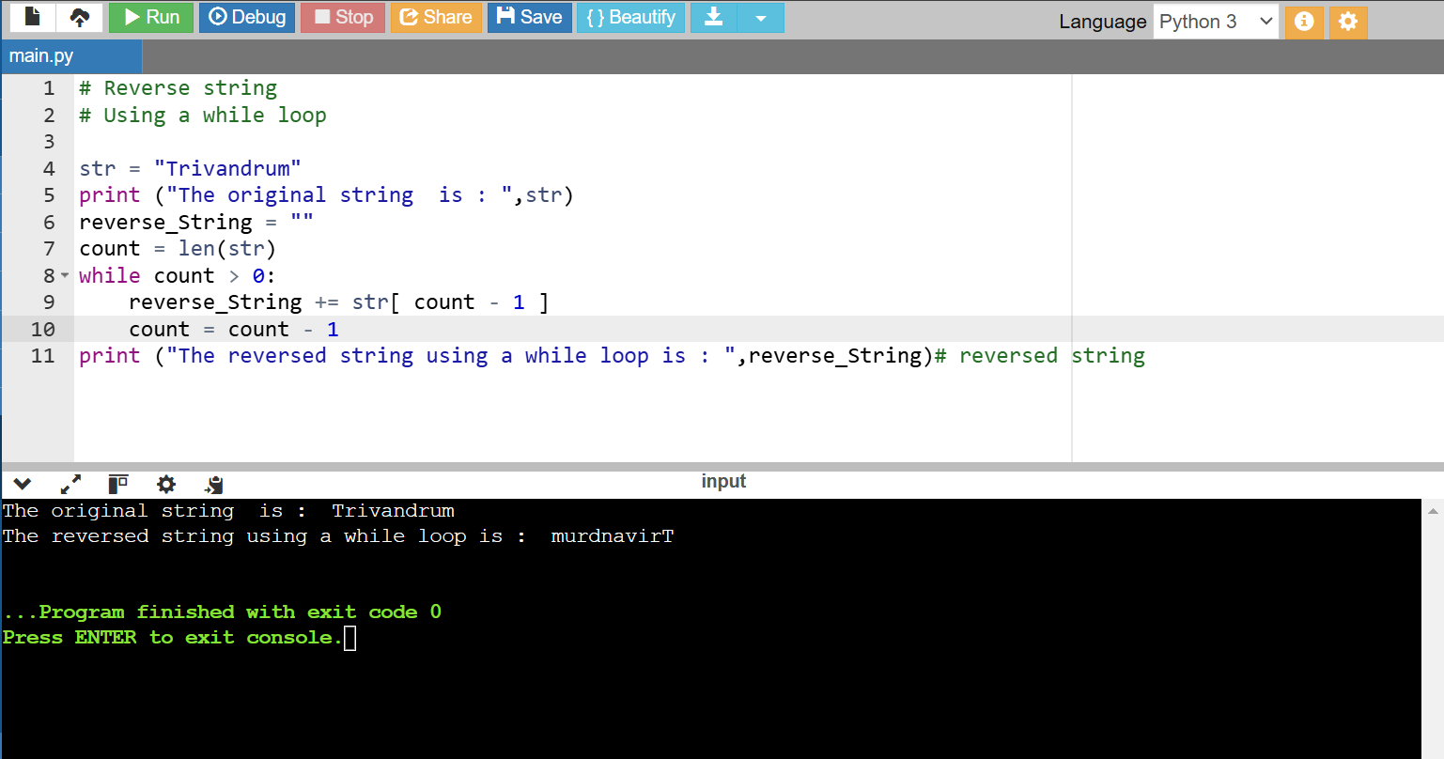

**3. Using the slice ([]) operator:**

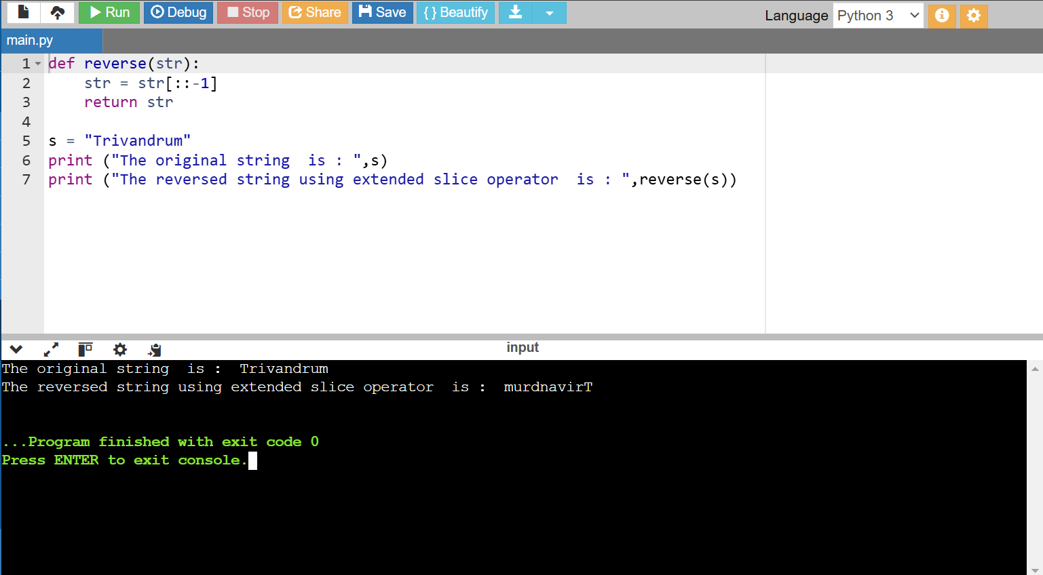

**4. Using reverse function with join:**

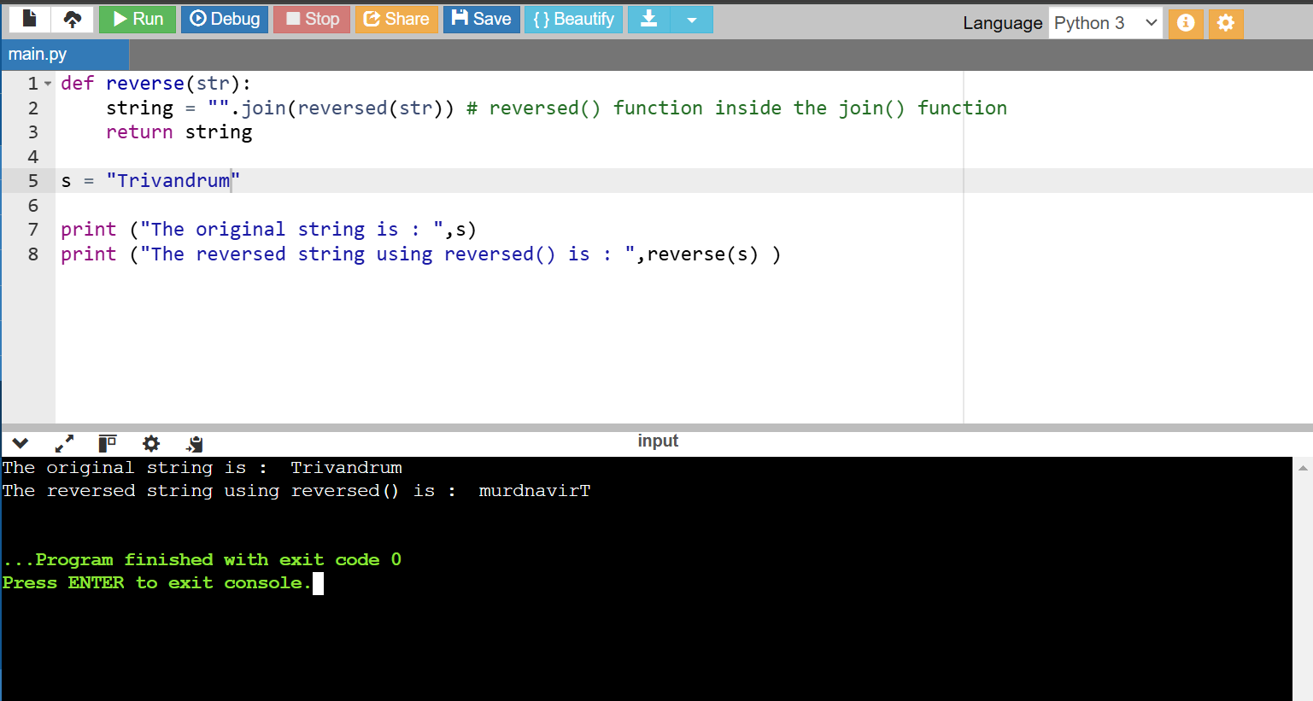

**5. Using recursion():**

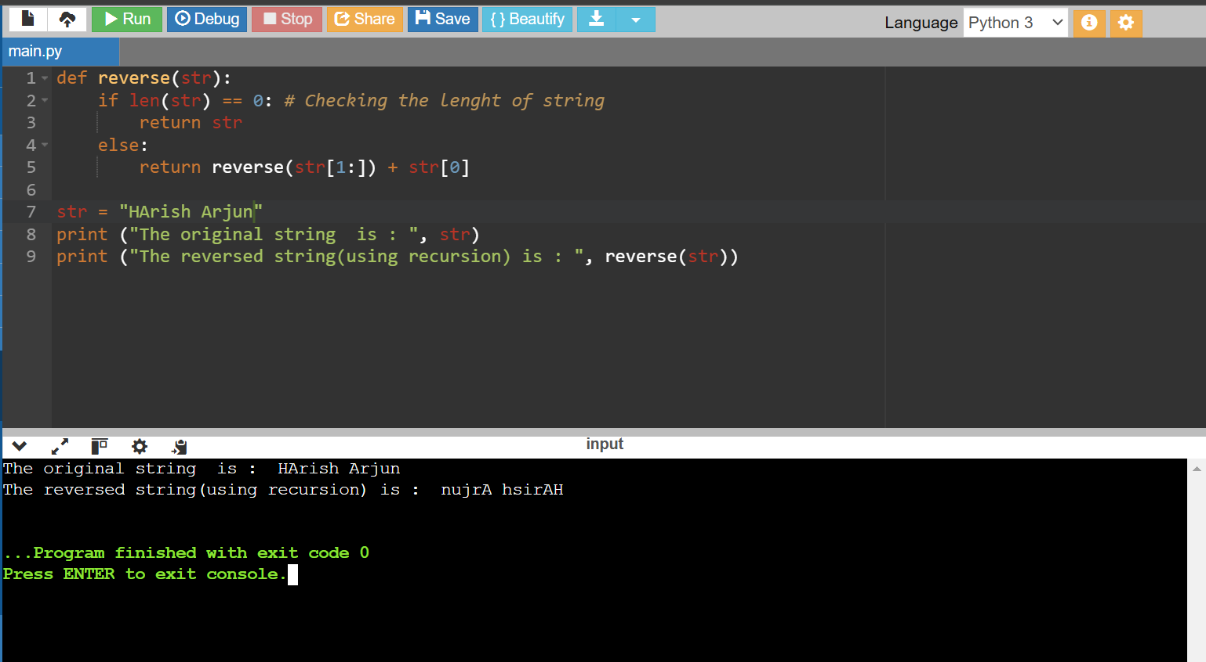

**PYTHON CSV FILE :**

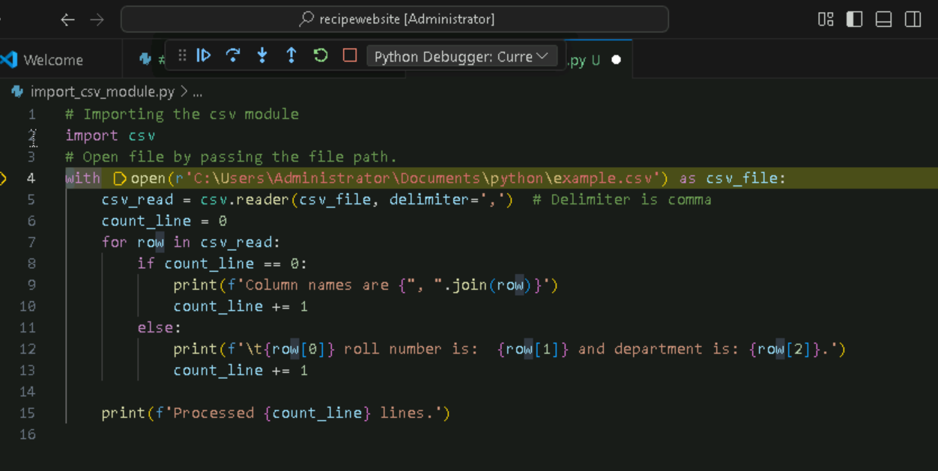

**Output:**

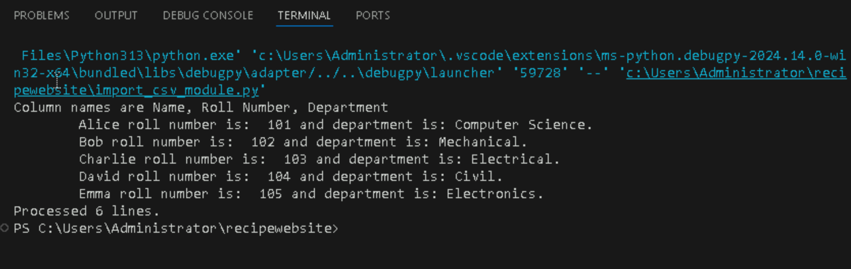

**Python IF-ELSE:**

**1. if statement:**

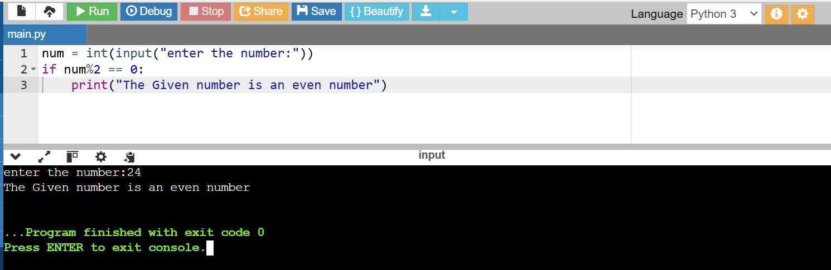

**2. print the largest of the three numbers**

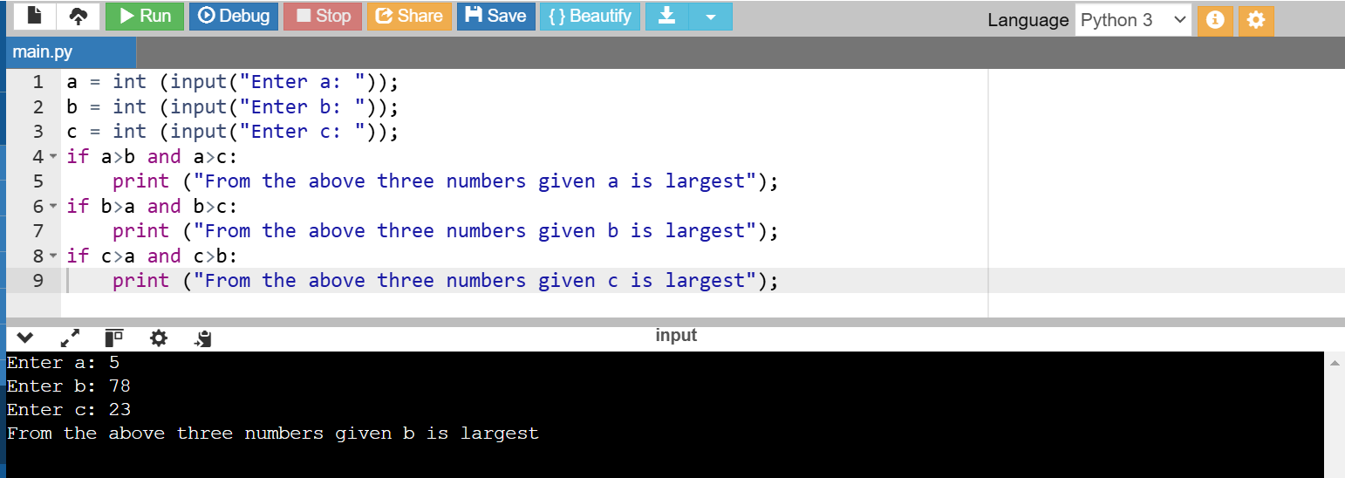

**If-Else statement:**

1.

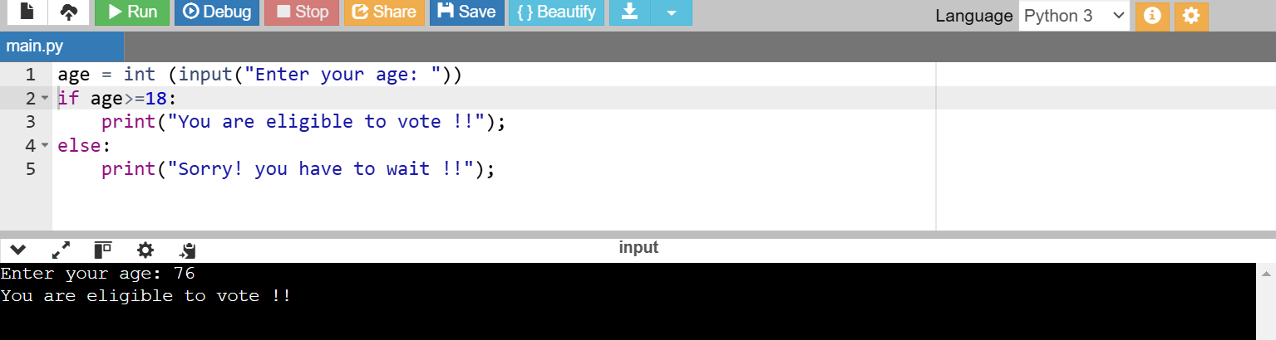

**2. check whether a number is even or not:**

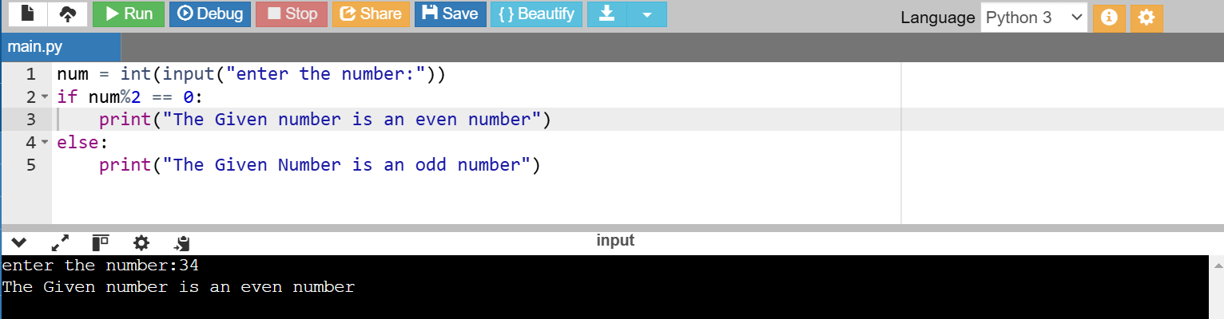

**Elif statement:**

**1.** 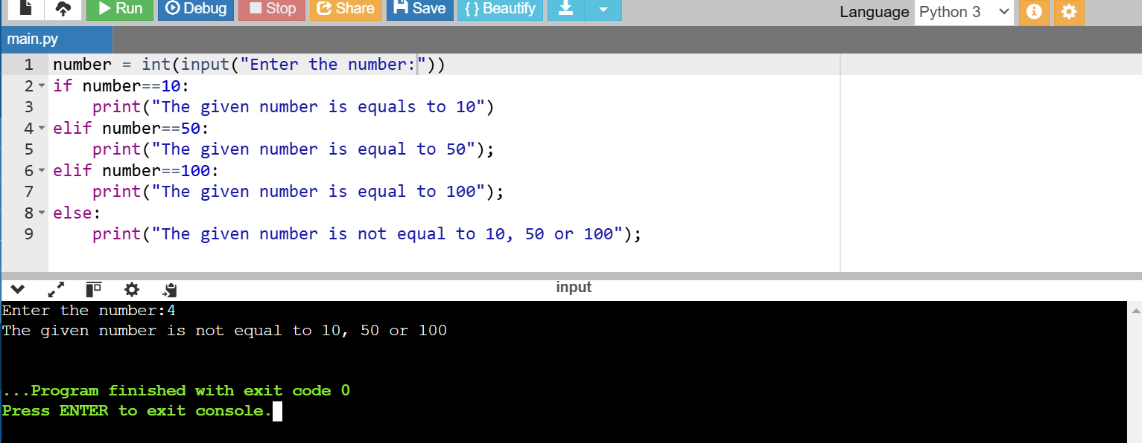

**2.** 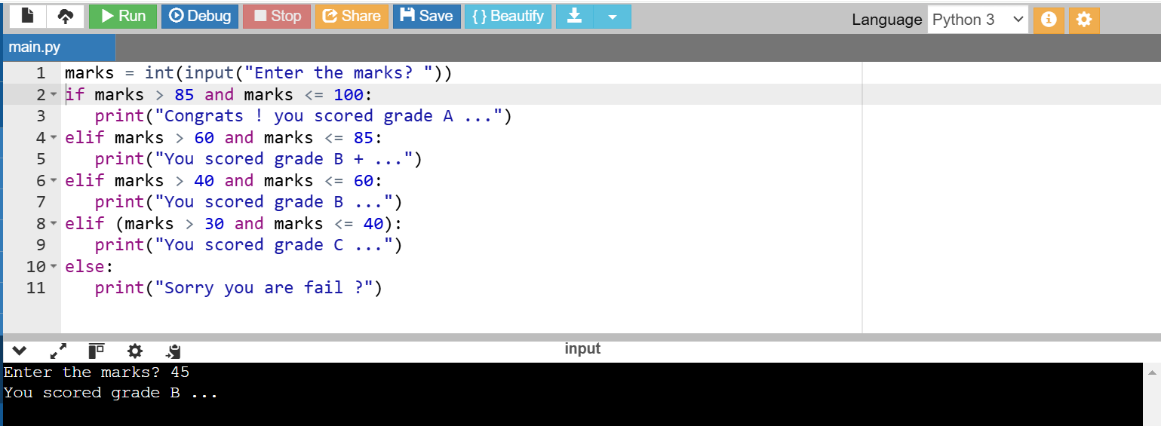

**WHILE LOOPS:**

**1. sum of squares:**

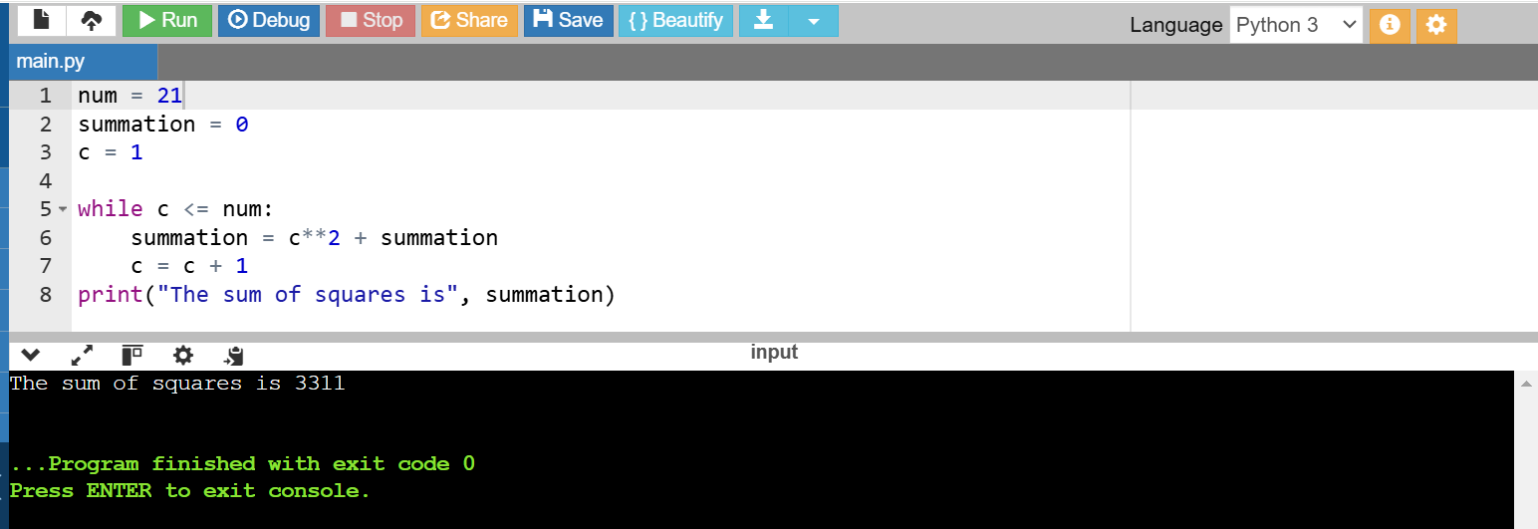

**2. Prime Numbers:**

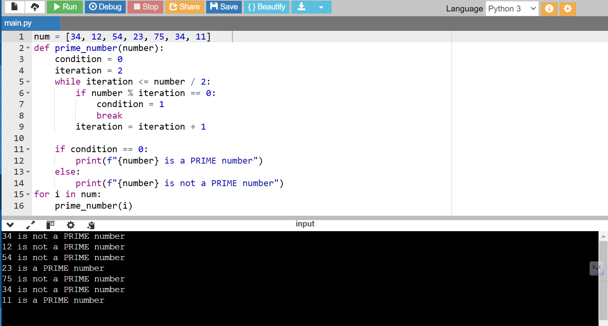

**3. Armstrong:**

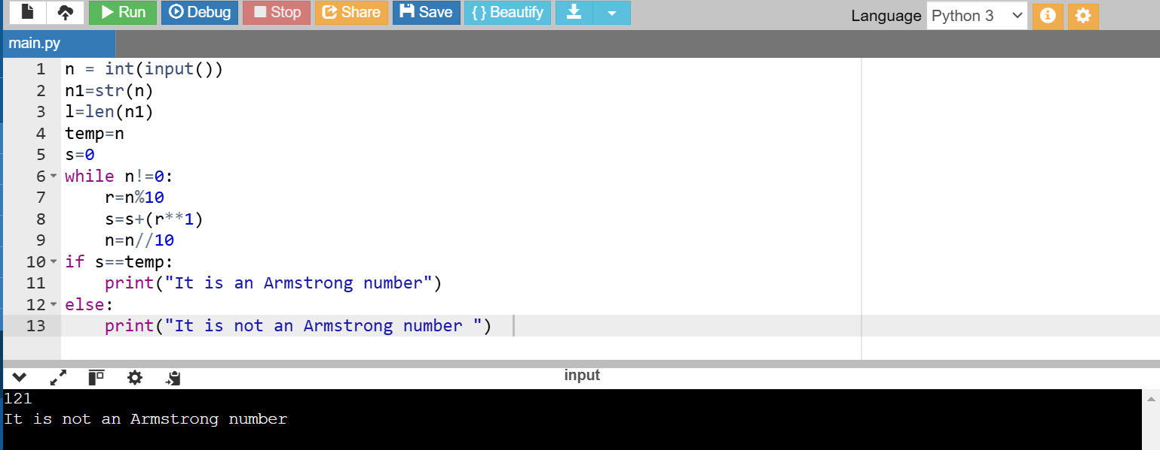

**4. Multiplication Table using While Loop:**

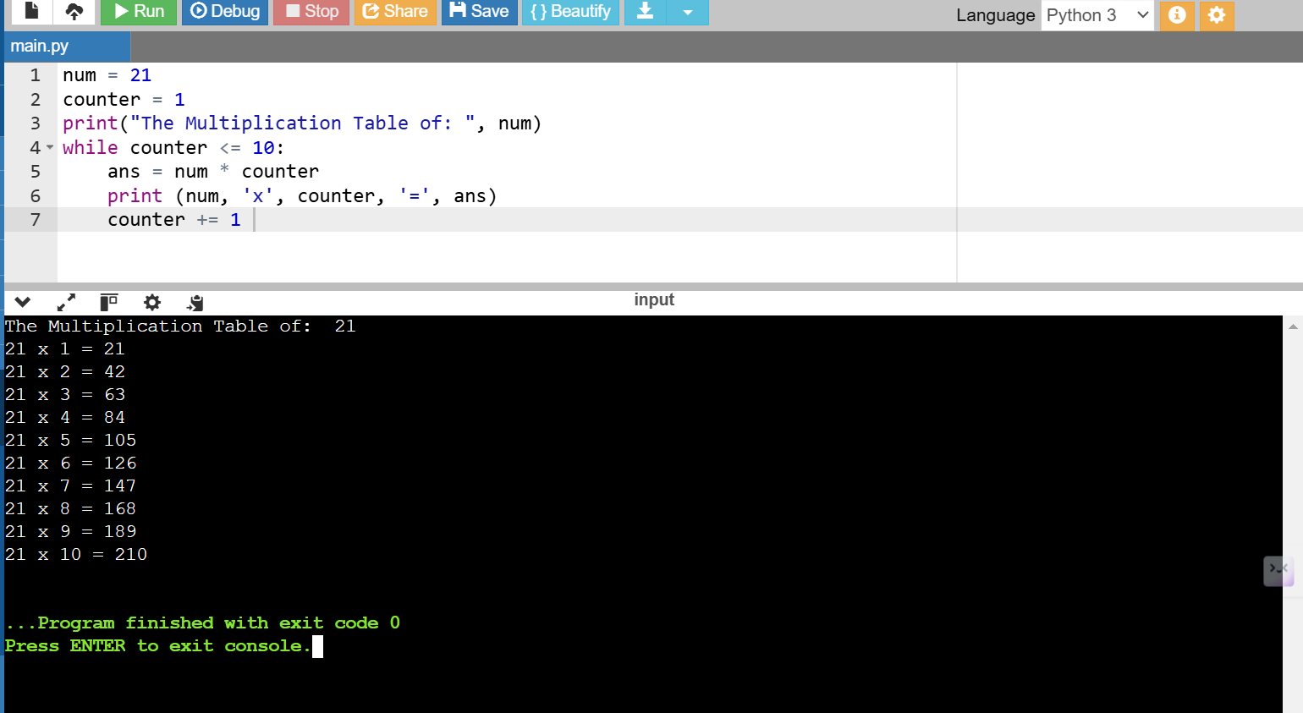

**5. Break Statement & Continue Statement:**

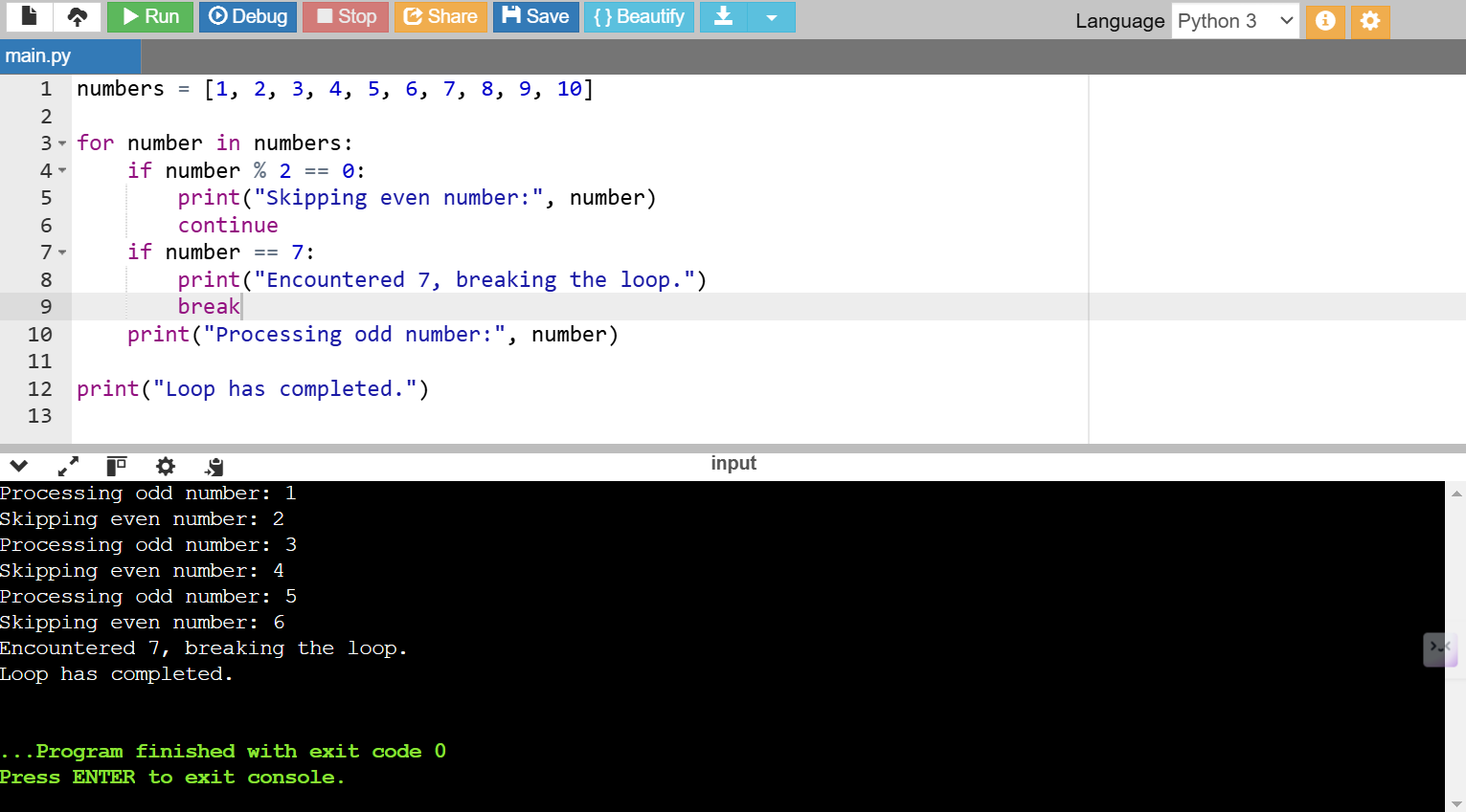

**FOR LOOPS:**

**1.**

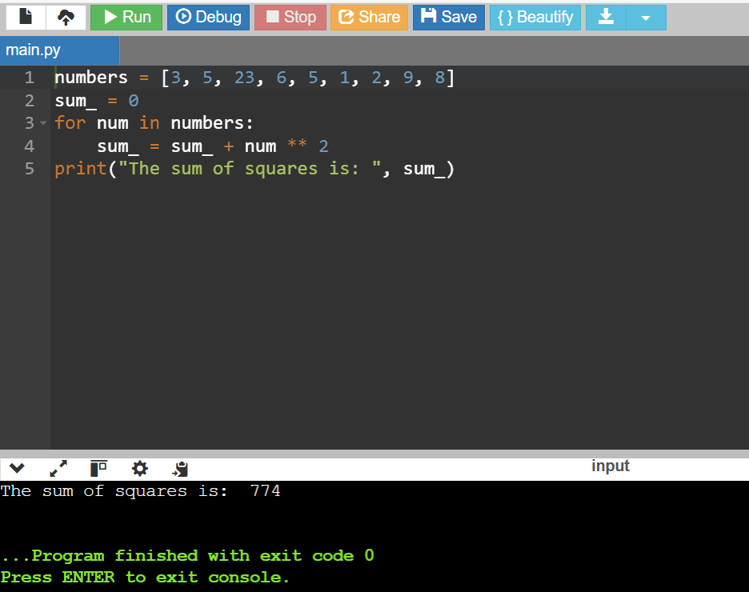

2.

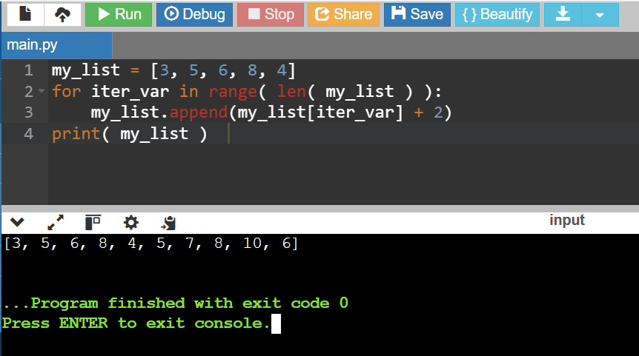

3.

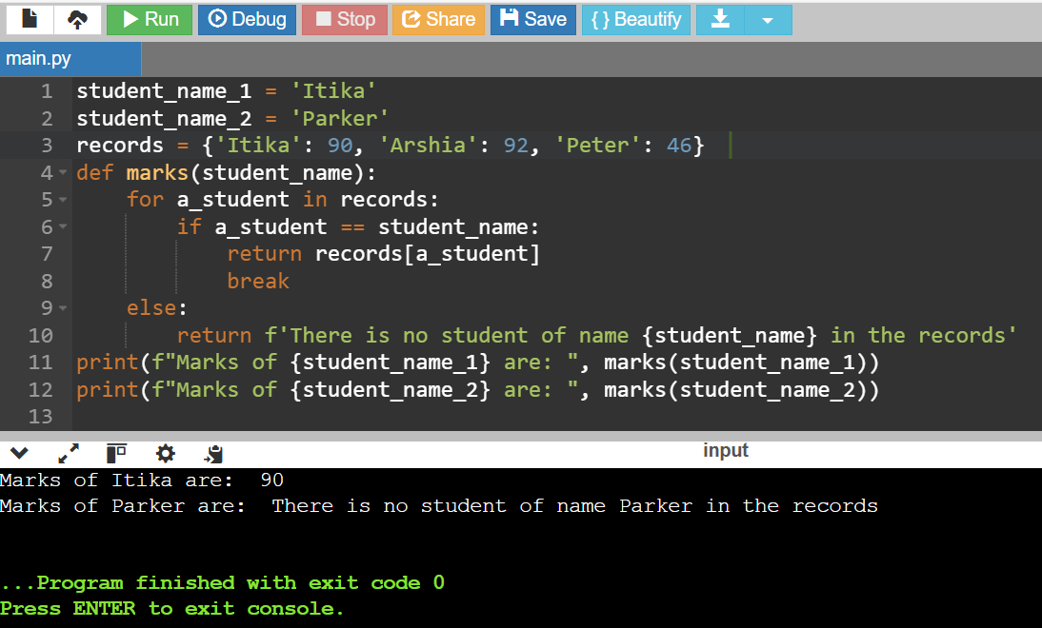

4.

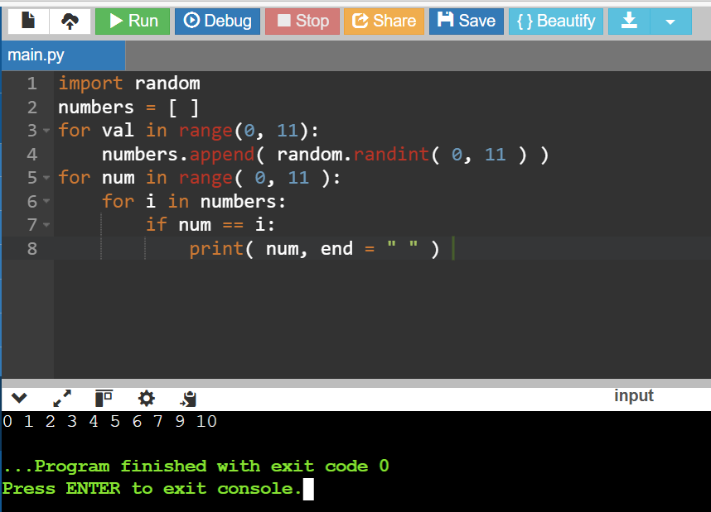

**STRINGS**

1. 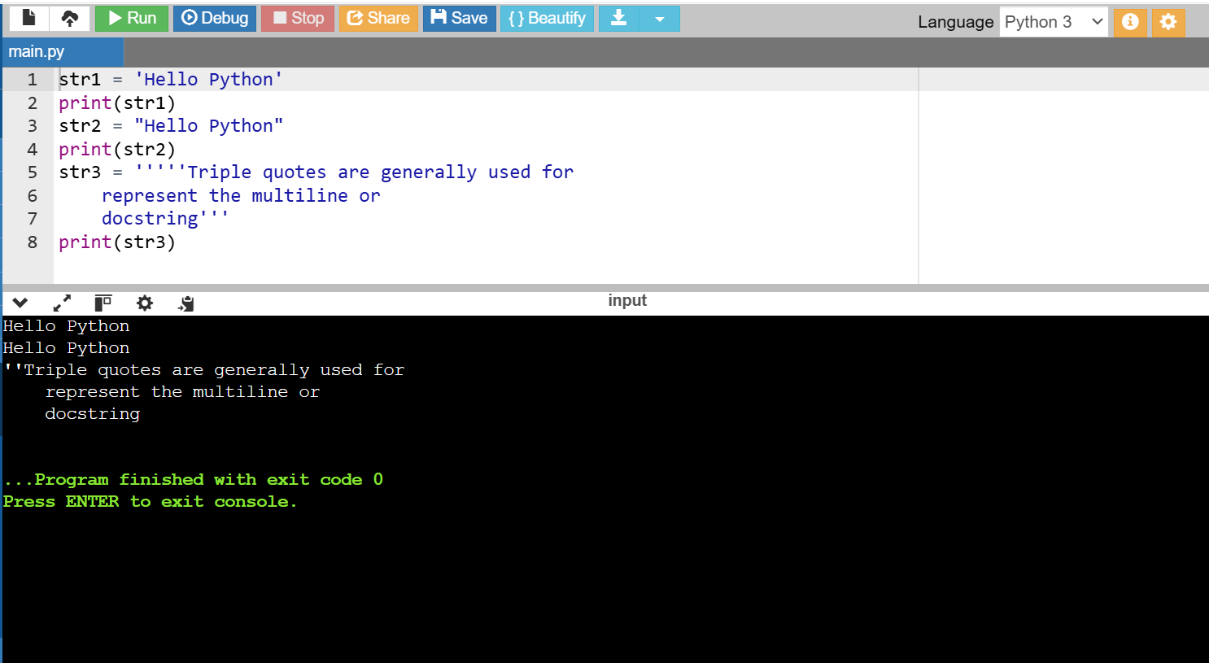

2. Indexing and Splitting:

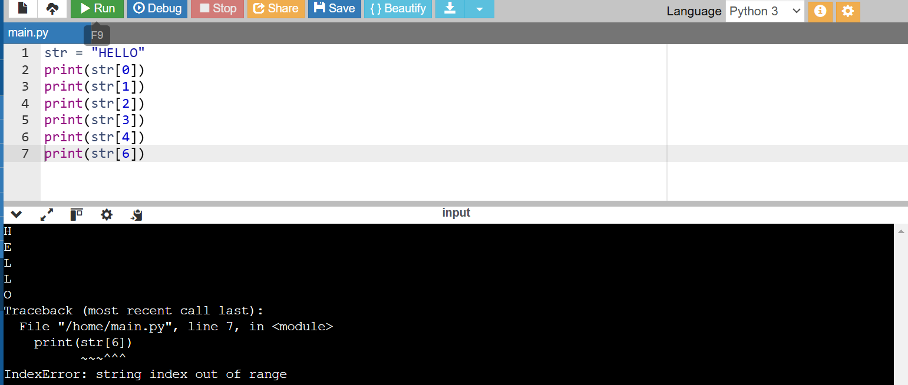

3. 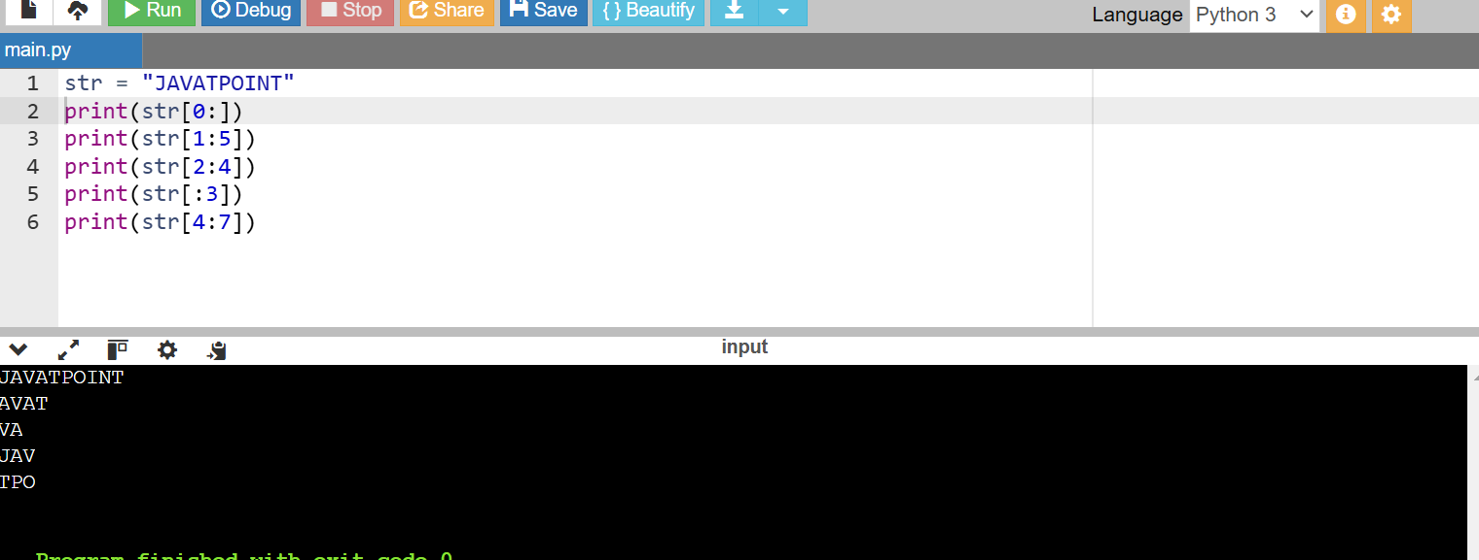

4. 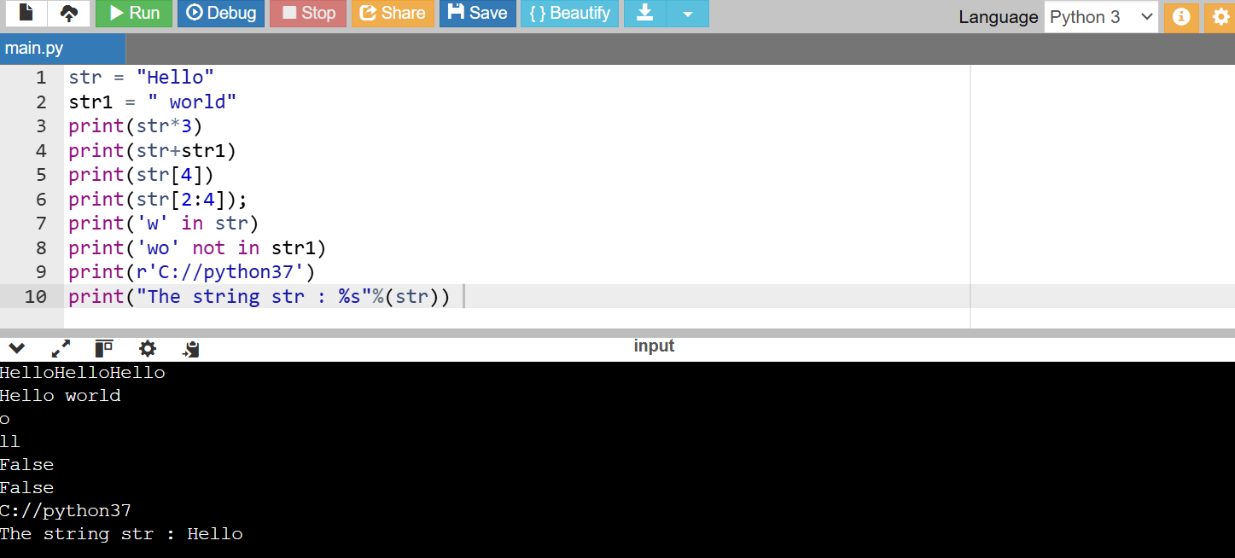

**Python List vs Tuple**

1. **List and Tuple Syntax Differences:**

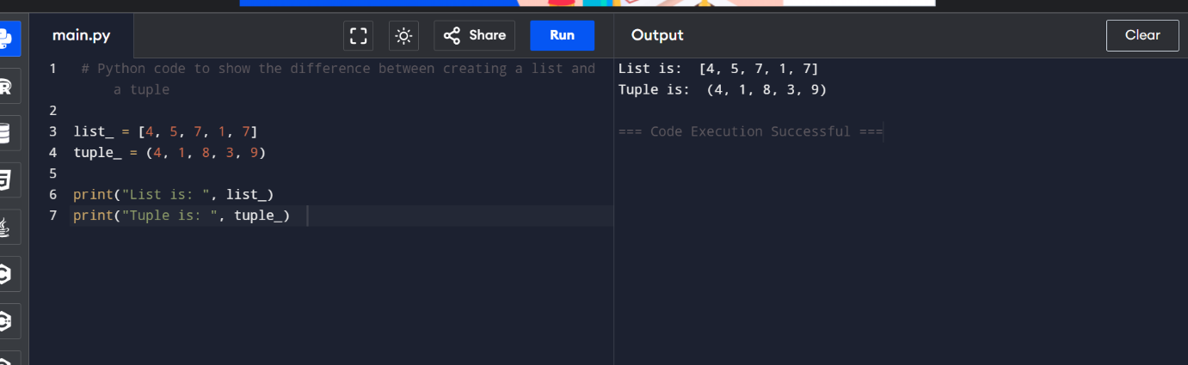

**2. Updating the element of list and tuple at a particular index :**

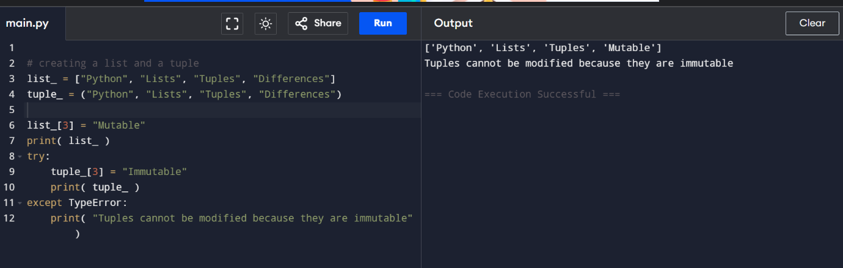

**3. Code to show the difference in the size of a list and a tuple:**

